Pennsylvania State University World Campus

IST 110

Hardware Dissection Lab

February 11, 2024

I picked the Xbox Series X and the Dell XPS 13 tear-down. These are two different devices. The Xbox is a gaming system with a greater body optimized for gaming, while the Dell XPS 13 is a thinner-body laptop that incorporates a lot of innovation pressed into it for compactness and efficiency. I did anticipate the inner engineering to be diverse and conversely. A few parts on the motherboard looked comparable, for illustration, both have their GPU soldered and they both utilize solid-state drives. I had a small challenge in finding and comprehending each component, and the iFixit manual helped direct me through the dismantling process, with a few of the parts indeed highlighted.The two gadgets have an incredible way of cooling themselves. The Xbox cooling fans and vents are colossal, the Dell XPS packs all this innovation in a little body whereas moreover keeping it cool.

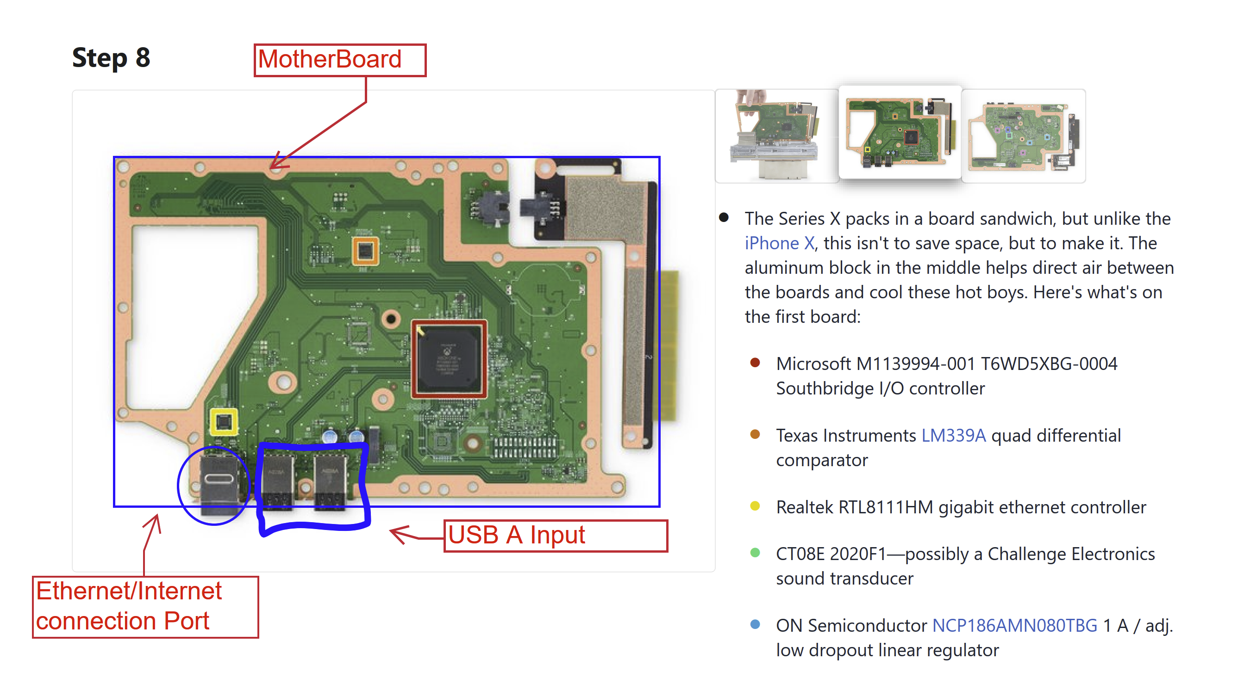

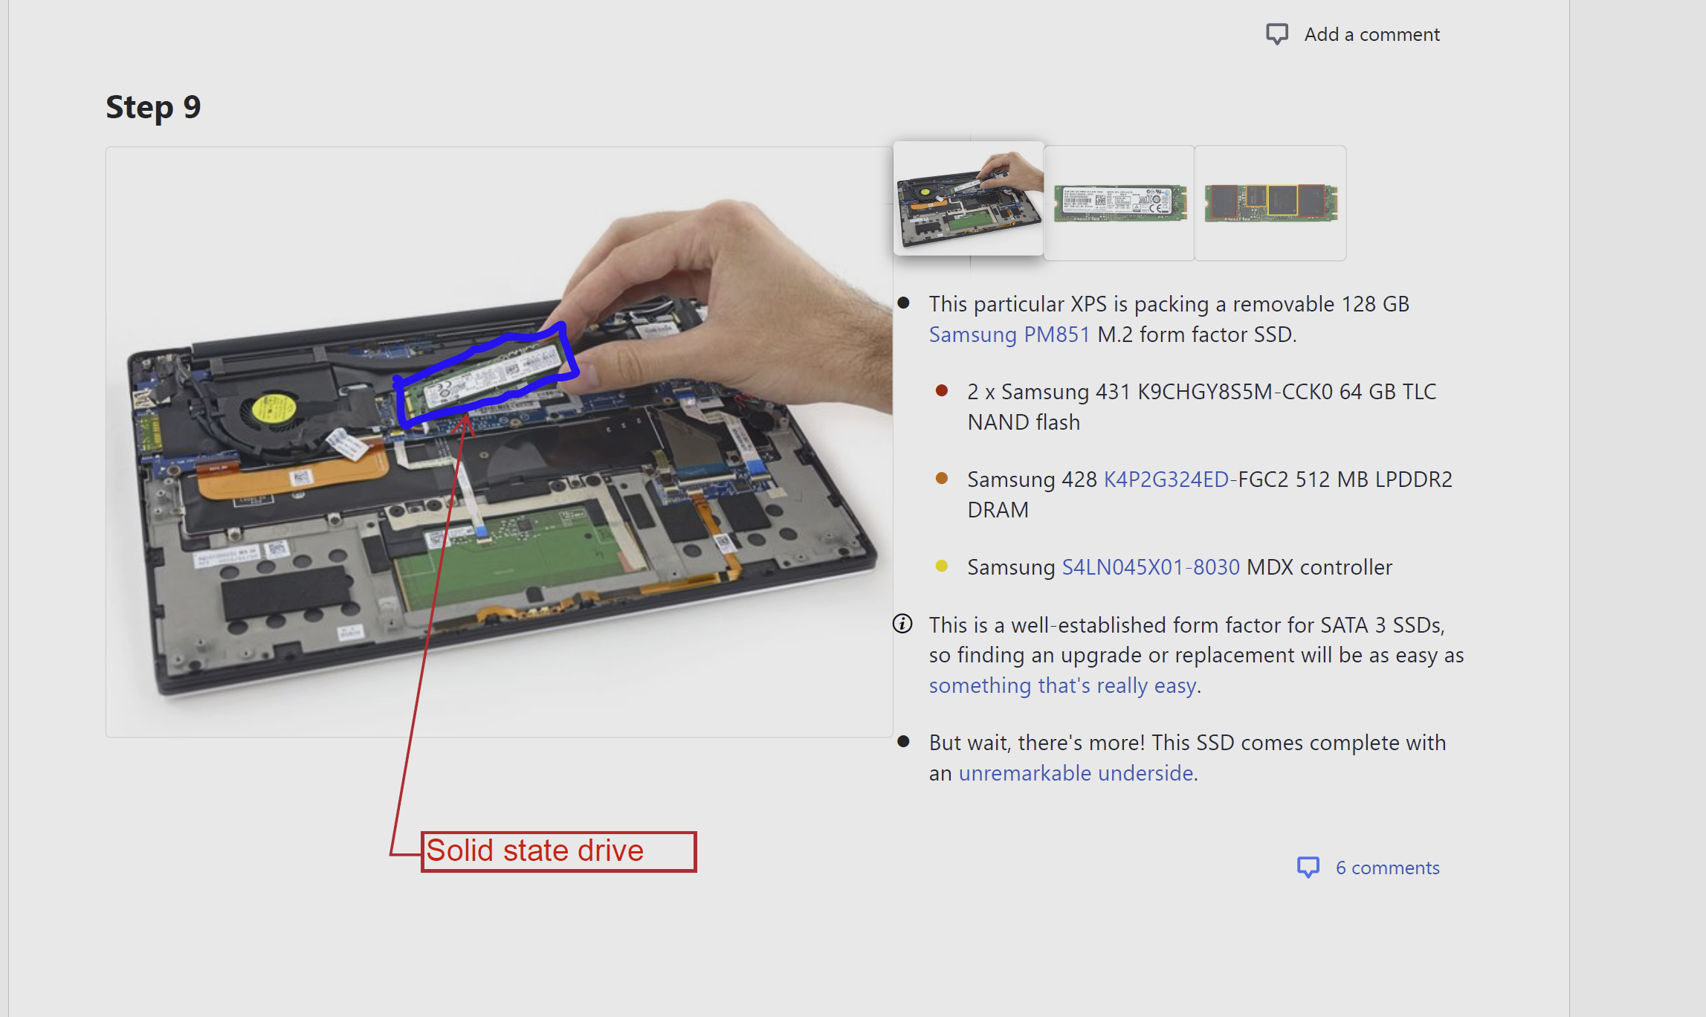

References

Goldheart , S. (2015, February 11). *Dell XPS 13 teardown*. iFixit. <https://www.ifixit.com/Teardown/Dell+XPS+13+Teardown/36157>

Frauenheim, C. (2020, November 11). *Xbox Series X Teardown*. IFixit. <https://www.ifixit.com/Teardown/Xbox+Series+X+Teardown/138451#s275556>